1. 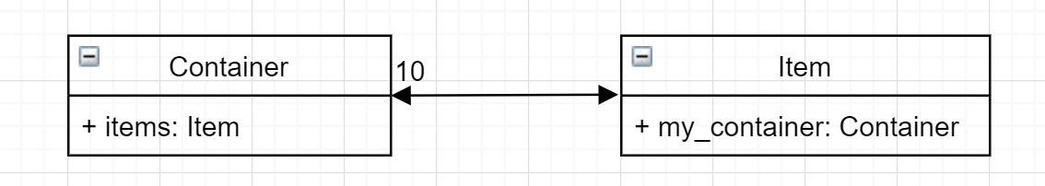
2. 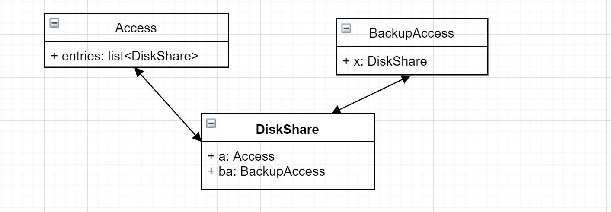
3. 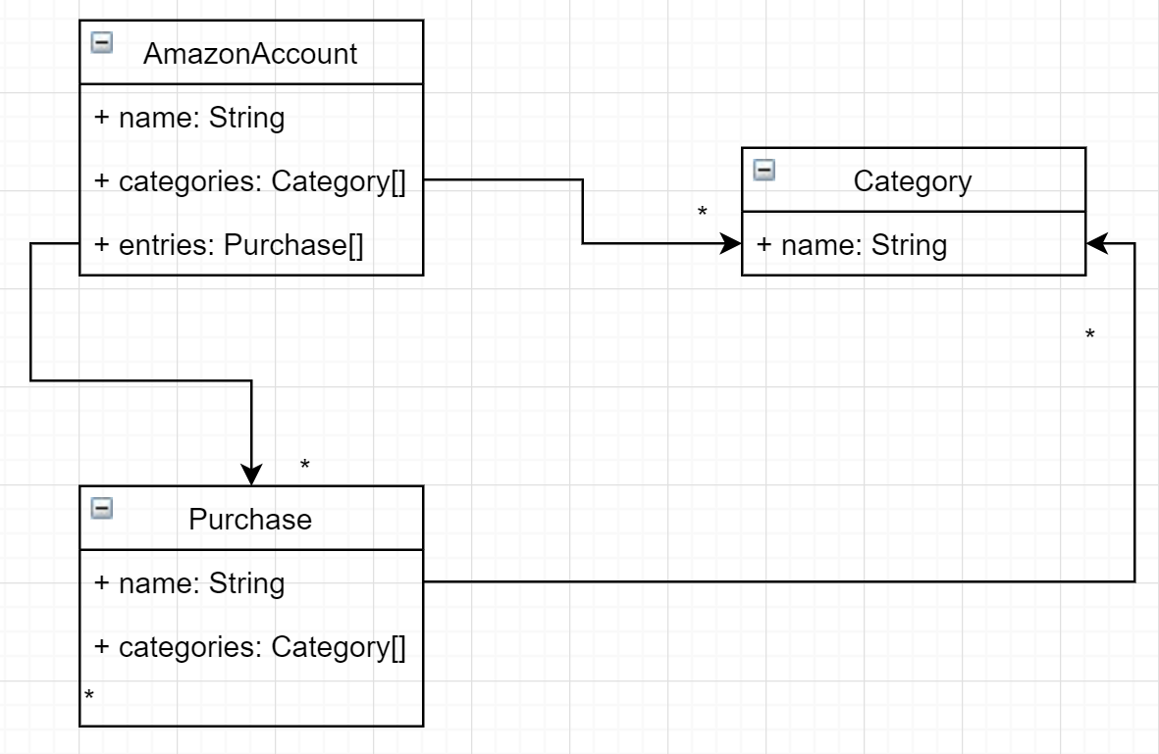
4. 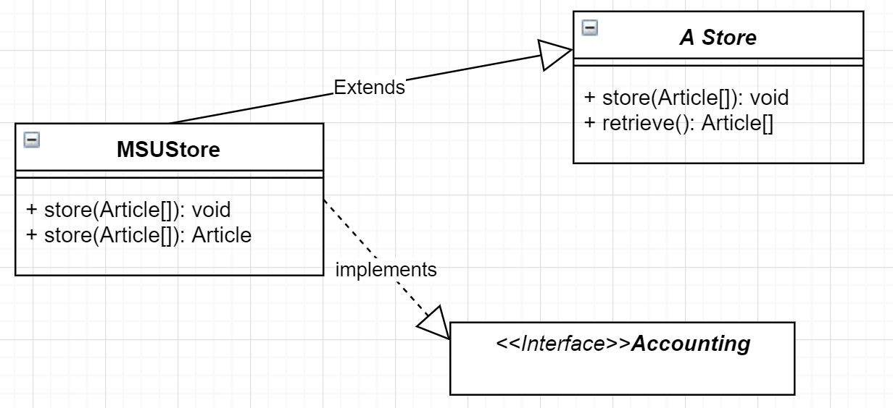

public class Company {

String name;

Address headquarters;

Employee employee;

Customer customer;

Truck truck;

Car car;

Motorbike motorbike;

}

public class Employee extends Person{

}

public class Subcontractor extends Employee{

}

public class Subcontractor extends Customer{

}

public class Person{

String name;

String email;

address;

}

public class Customer extends Person{

BankAccount bankAccount;

}

public class BankAccount{

UnlimitedNatural number;

String despositor;

String bank;

}

public class Address{

String street;

String postalCode;

String city;

}

public class VehicleRentalService extends Service{

Vehicle vehicle;

offerCare()

offerMotorbike()

offerTruck()

}

public class Service{

Customer customer;

}

public interface Rentable{

rent()

}

public class Vehicle implements Rentable{

}

public class Truck extends Vehicle{

UnlimitedNatural weight;

UnlimitedNatural power;

String manufacturer;

String regNo;

}

public class Car{

CarKind kind;

UnlimitedNatural noSeats;

UnlimitedNatural power;

String manufacturer;

String regNo;

}

public class motorbike{

MbKind kind;

UnlimitedNatural cylinderCap;

UnlimitedNatural power;

String manufacturer;

String regNo;

}